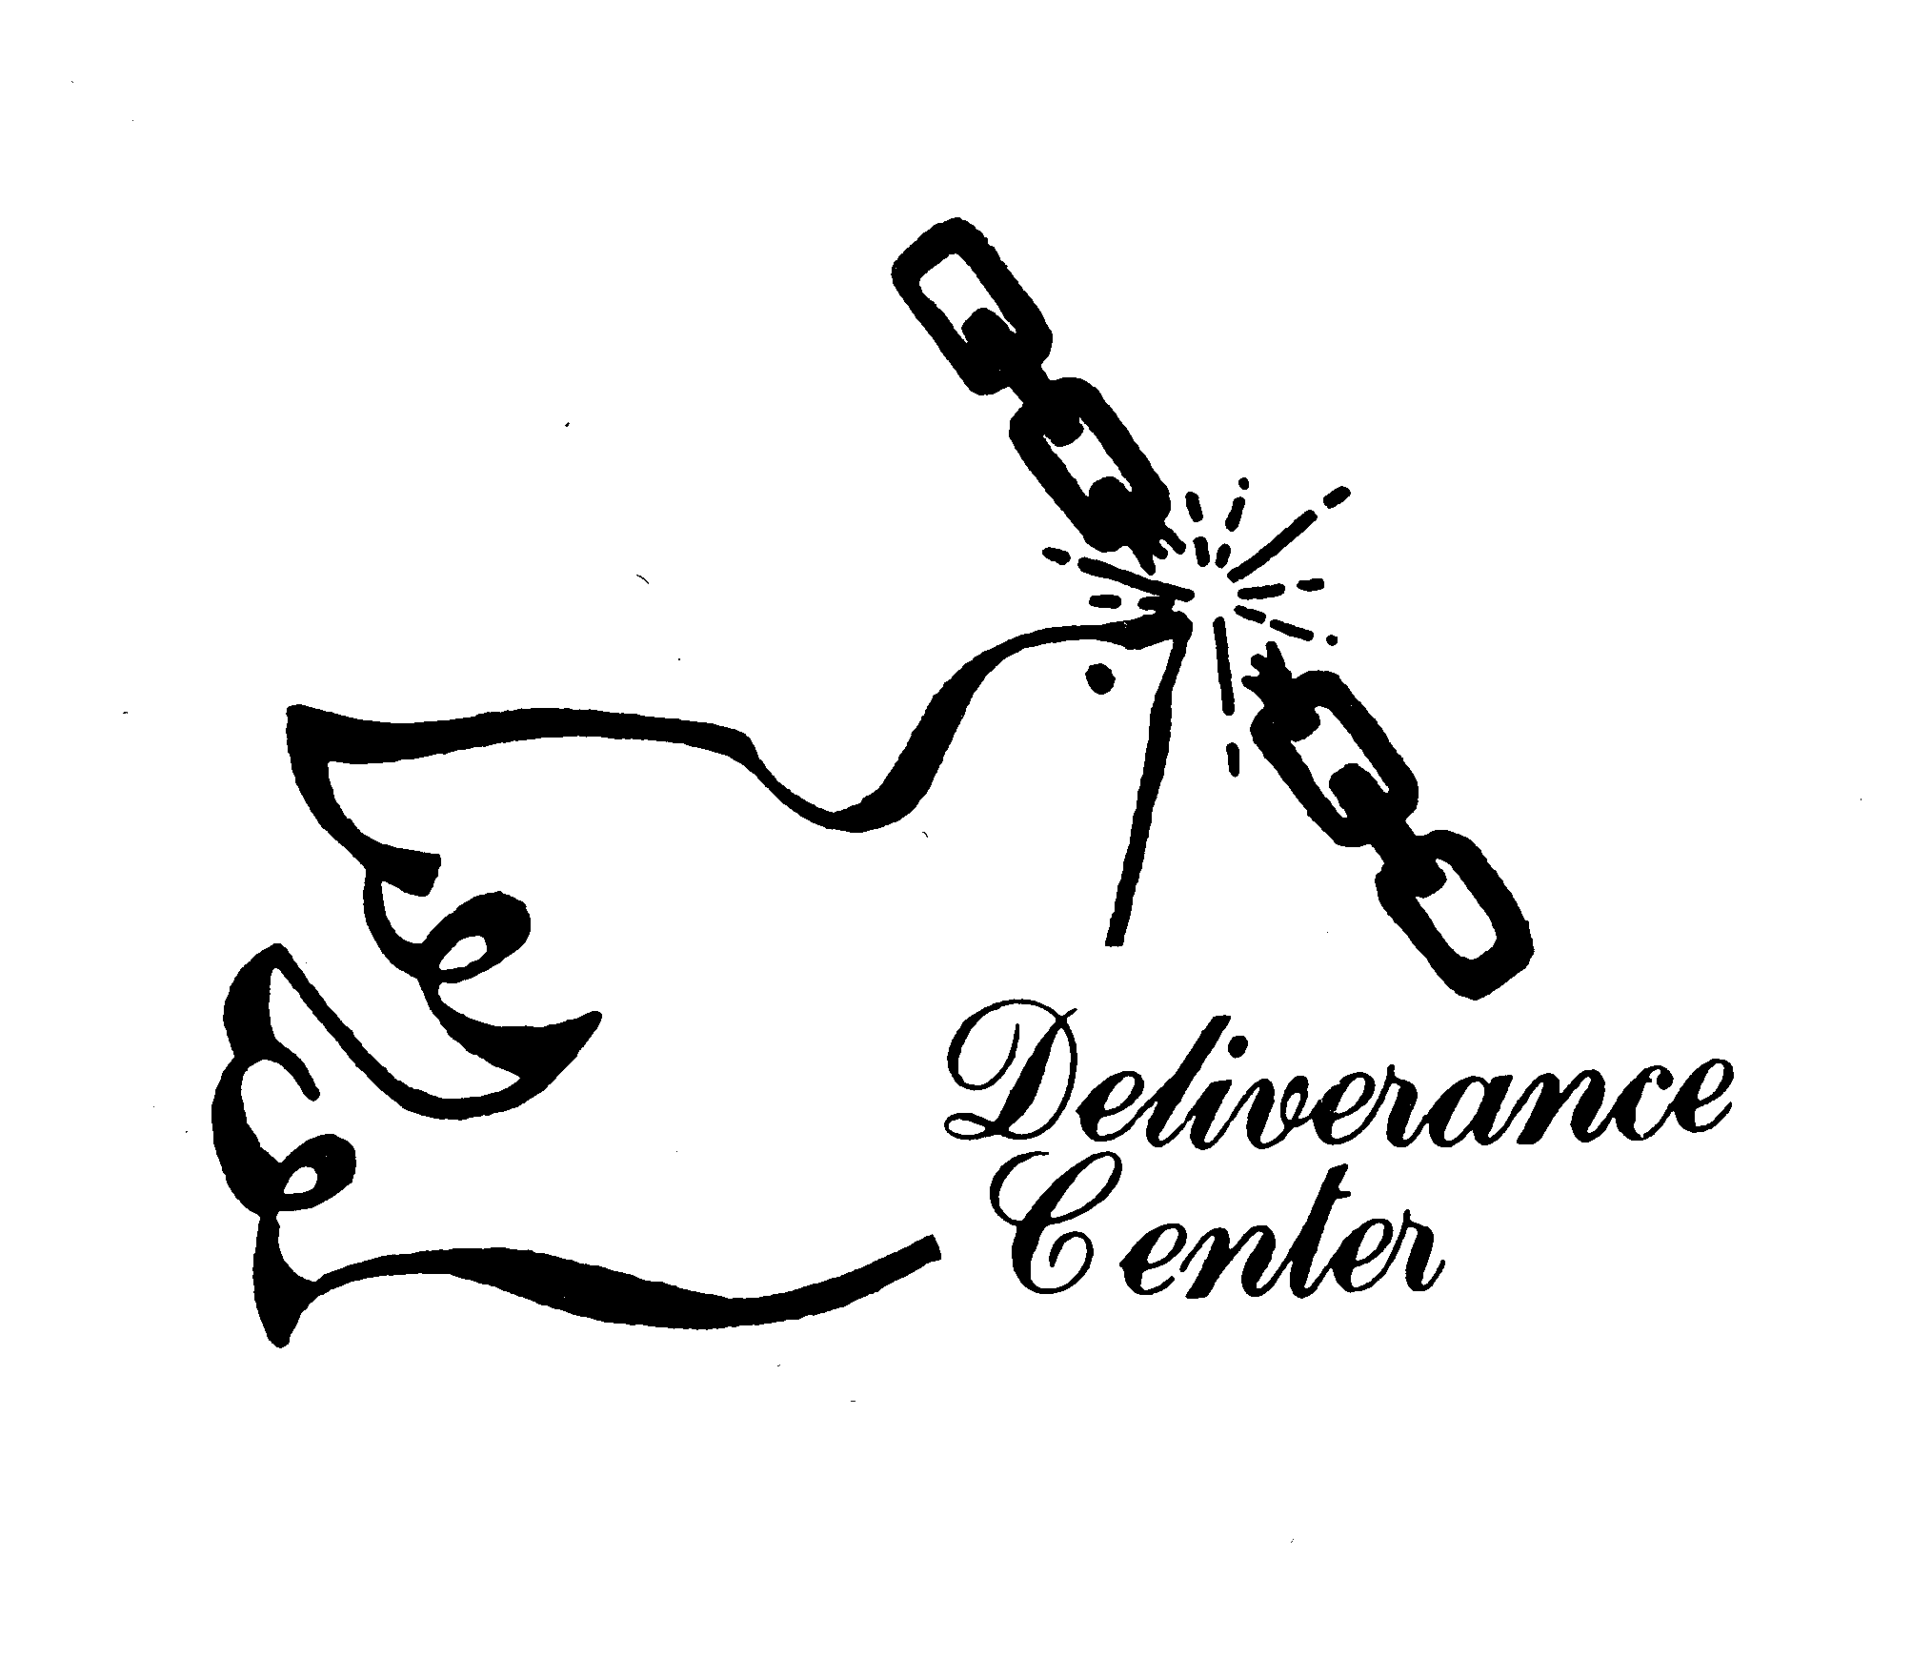
DELIVERANCE CENTER, INC.
1008 CONGRESS STREET  PORTLAND, MAINE
CERTIFIES THAT
Rev. James R. Reynolds, Sr.
is hereby recognized by the Deliverance Center, Inc. as an
Ordained Minister of the Gospel.
Rev. James R. Reynolds, Sr.
Valid only when signed.

DELIVERANCE CENTER, INC.
1008 CONGRESS STREET  PORTLAND, MAINE
CERTIFIES THAT
Rev. James R. Reynolds, Sr.
is hereby recognized by the Deliverance Center, Inc. as an
Ordained Minister of the Gospel.
Rev. James R. Reynolds, Sr.
Valid only when signed.

DELIVERANCE CENTER, INC.
1008 CONGRESS STREET  PORTLAND, MAINE
CERTIFIES THAT
Rev. Stephen G. Reynolds, Sr.
is hereby recognized by the Deliverance Center, Inc. as an
Ordained Minister of the Gospel.
Rev. James R. Reynolds, Sr.
Valid only when signed.

DELIVERANCE CENTER, INC.
1008 CONGRESS STREET  PORTLAND, MAINE
CERTIFIES THAT
Rev. Stephen G. Reynolds, Sr.
is hereby recognized by the Deliverance Center, Inc. as an
Ordained Minister of the Gospel.
Rev. James R. Reynolds, Sr.
Valid only when signed.

DELIVERANCE CENTER, INC.
1008 CONGRESS STREET  PORTLAND, MAINE
CERTIFIES THAT
Rev. James R. Reynolds, Jr.
is hereby recognized by the Deliverance Center, Inc. as an
Ordained Minister of the Gospel.
Rev. James R. Reynolds, Sr.
Valid only when signed.
DELIVERANCE CENTER, INC.
1008 CONGRESS STREET  PORTLAND, MAINE
CERTIFIES THAT
Rev. James R. Reynolds, Jr.
is hereby recognized by the Deliverance Center, Inc. as an
Ordained Minister of the Gospel.
Rev. James R. Reynolds, Sr.
Valid only when signed.

